Case study on Text Classification Using NLP
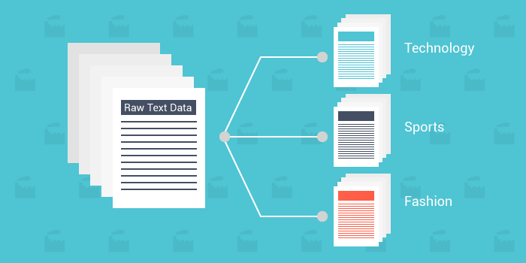

What is Text Classification?
Text Classification is an automated process of classification of text into predefined categories. We can classify Emails into spam or non-spam, news articles into different categories like Politics, Stock Market, Sports, etc.
STEP -1 : Add the Required Libraries
The following libraries will be used ahead in the article. If not available, these can be easily downloaded through their respective websites.
import pandas as pd
import numpy as np
from nltk.tokenize import word_tokenize
from nltk import pos_tag
from nltk.corpus import stopwords
from nltk.stem import WordNetLemmatizer
from sklearn.preprocessing import LabelEncoder
from collections import defaultdict
from nltk.corpus import wordnet as wn
from sklearn.feature_extraction.text import TfidfVectorizer
from sklearn import model_selection, naive_bayes, svm
from sklearn.metrics import accuracy_score
STEP -2: Set random seed
This is used to reproduce the same result every time if the script is kept consistent otherwise each run will produce different results. The seed can be set to any number.
np.random.seed(500)
STEP -3: Add the Corpus
The data set can be easily added as a pandas Data Frame with the help of ‘read_csv’ function. I have set the encoding to ‘latin-1’ as the text had many special characters.
Corpus = pd.read_csv(r"C:\Users\gunjit.bedi\Desktop\NLP Project\corpus.csv",encoding='latin-1')
STEP -4: Data pre-processing
This is an important step in any data mining process. This basically involves transforming raw data into an understandable format for NLP models. Real-world data is often incomplete, inconsistent, and/or lacking in certain behaviors or trends, and is likely to contain many errors. Data pre-processing is a proven method of resolving such issues.This will help in getting better results through the classification algorithms.
Below, I have explained the two techniques that are also performed besides other easy to understand steps in data pre-processing:
- Tokenization: This is a process of breaking a stream of text up into words, phrases, symbols, or other meaningful elements called tokens. The list of tokens becomes input for further processing. NLTK Library has word_tokenize and sent_tokenize to easily break a stream of text into a list of words or sentences, respectively.
- Word Stemming/Lemmatization: The aim of both processes is the same, reducing the inflectional forms of each word into a common base or root. Lemmatization is closely related to stemming. The difference is that a stemmer operates on a single word without knowledge of the context, and therefore cannot discriminate between words which have different meanings depending on part of speech. However, stemmers are typically easier to implement and run faster, and the reduced accuracy may not matter for some applications.
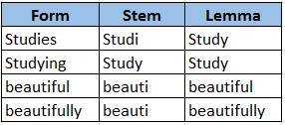
Lemma performs better
Here’s the complete script which performs the aforementioned data pre-processing steps, you can always add or remove steps which best suits the data set you are dealing with:
- Remove Blank rows in Data, if any
- Change all the text to lower case
- Word Tokenization
- Remove Stop words
- Remove Non-alpha text
- Word Lemmatization
# Step - a : Remove blank rows if any.
Corpus['text'].dropna(inplace=True)
# Step - b : Change all the text to lower case. This is required as python interprets 'dog' and 'DOG' differently
Corpus['text'] = [entry.lower() for entry in Corpus['text']]
# Step - c : Tokenization : In this each entry in the corpus will be broken into set of words
Corpus['text']= [word_tokenize(entry) for entry in Corpus['text']]
# Step - d : Remove Stop words, Non-Numeric and perfom Word Stemming/Lemmenting.
# WordNetLemmatizer requires Pos tags to understand if the word is noun or verb or adjective etc. By default it is set to Noun
tag_map = defaultdict(lambda : wn.NOUN)
tag_map['J'] = wn.ADJ
tag_map['V'] = wn.VERB
tag_map['R'] = wn.ADV
for index,entry in enumerate(Corpus['text']):
# Declaring Empty List to store the words that follow the rules for this step
Final_words = []
# Initializing WordNetLemmatizer()
word_Lemmatized = WordNetLemmatizer()
# pos_tag function below will provide the 'tag' i.e if the word is Noun(N) or Verb(V) or something else.
for word, tag in pos_tag(entry):
# Below condition is to check for Stop words and consider only alphabets
if word not in stopwords.words('english') and word.isalpha():
word_Final = word_Lemmatized.lemmatize(word,tag_map[tag[0]])
Final_words.append(word_Final)
# The final processed set of words for each iteration will be stored in 'text_final'
Corpus.loc[index,'text_final'] = str(Final_words)
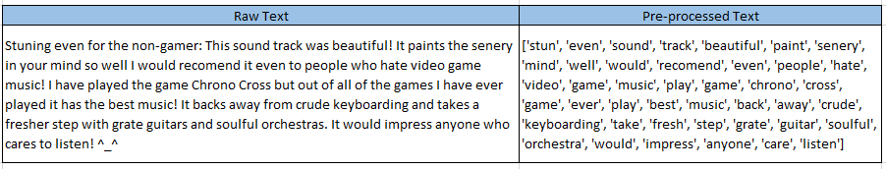
Text after all the pre-processing steps are performed
STEP -5: Prepare Train and Test Data sets
STEP -6: Encoding
STEP -7: Word Vectorization
STEP -8: Use the ML Algorithms to predict the outcome

